MAJOR PROJECT VALIDATION FORM

Supervisor Name |  | Panel Head
 | Dr Mohammad Shahnawaz Hussain
 | Faculty Advisor | Project Domain
 | Dr Sumathy G | SDG – 4 Quality Education
M
 | Student(s) Details: Name | Passport size photo(s)
 | - Atharv Dobhal  - Divyansh Bafila |   

Registration Number(s)

1. RA2211047010134
2. RA2211047010068

Email ID(s)&Mobile Number(s)
1: ad6801@srmist.edu.in | 2: db9533@srmist.edu.in

1 | Abstract | Visionary Career Assistance is an advanced career guidance platform that integrates data analytics and mentorship to help students make informed career decisions. It combines a Data-Driven Analysis Dashboard and a Mentor Connections Platform to analyze role model influences, socioeconomic backgrounds, and behavioral trends. Built using React and TypeScript for the frontend and Flask with Python for the backend, it employs sentiment analysis, machine learning, and data visualization to deliver personalized insights. The platform promotes equity, supports SDG 4,and ensures mobile responsiveness with real-time analytics.
2 | RESEARCH GAP  (not more than 3 points) | 1. Existing career guidance systems largely rely on academic performance and subjective counseling, lacking integration of socio-economic, behavioral, and role-model factors for holistic assessment.  2. Limited use of statistical and sentiment-based analytics, such as hierarchical regression, prevents quantification of the relative impact of multiple factors on student career confidence.  3. Current platforms do not provide interactive dashboards, reproducible analytics pipelines, or automated reporting for mentors and institutions to make data-driven, personalized guidance decisions.
3 | Please furnish the details of 5 research articles in IEEE Reference format with Impact factor and year of publication from Which Research gap has been identified (F. Lastname, “Title of article,” *Journal Name*, vol., no., pp., year. And IF 3.1)) / 5 Patent Details for highlighting the innovation | 1. S. H. Faruque, S. A. Khushbu, and S. Akter, “Unlocking Futures: A Natural Language Driven Career Prediction System for Computer Science and Software Engineering Students,” arXiv preprint, May 2024.  2. Z. Wang, Z. Zeng, Y. Li, and Z. Ding, “CareerPooler: AI-Powered Metaphorical Pool Simulation Improves Experience and Outcomes in Career Exploration,” arXiv preprint, Sep. 2025.  3. A. Kannan, C. C. Jet, K. Ramakrishnan, and S. Ramdass, “Predicting Student’s Soft Skills Based on Socio-Economical Factors: An Educational Data Mining Approach,” Int. J. Informatics Visualization, 2025.  4. SAIL-Y: A Socioeconomic and Gender-Aware Career Recommender System,” Electronics, MDPI, 2023.  5. R. Angeline, R. Charanya, K. S. Abhinaya, and L. S. Chowdary, “Career Mapping and Enhancing Personalized Education through Machine Learning-Based Recommendation Systems,” Proceedings of the 2025 International Conference on Advanced Research in Electronics and Communication Systems (ICARECS-2025), Atlantis Press, 2025, pp. 638–648. DOI: 10.2991/978-94-6463-754-0_56.
4 | Bridging the Research Gap/ Innovation Gap  (not more than 3 points) | 1. Integrates socio-economic, behavioral, academic, and role-model factors into a unified, data-driven framework to holistically assess student career confidence.  2. Applies hierarchical regression and sentiment-based analytics to quantify multi-level influences on career confidence, providing explainable, research-backed insights.  3. Offers interactive dashboards, reproducible analytics pipelines, and automated reporting for mentors and institutions, enabling personalized, evidence-based career guidance.
5 | OBJECTIVE  (not more than 5 points) | 1. Collect and validate structured survey data covering student background, behavior, academics, income, and role models.  2. Apply statistical and sentiment-based analytics to quantify individual and cohort-level career confidence.  3. Implement hierarchical regression to identify the relative influence of socio-economic and behavioral factors.  4. Develop interactive dashboards and reports for mentors and institutions to support data-driven guidance.  5. Enable automated, reproducible analytics and personalized recommendations for career counseling.
6 | System Architecture | 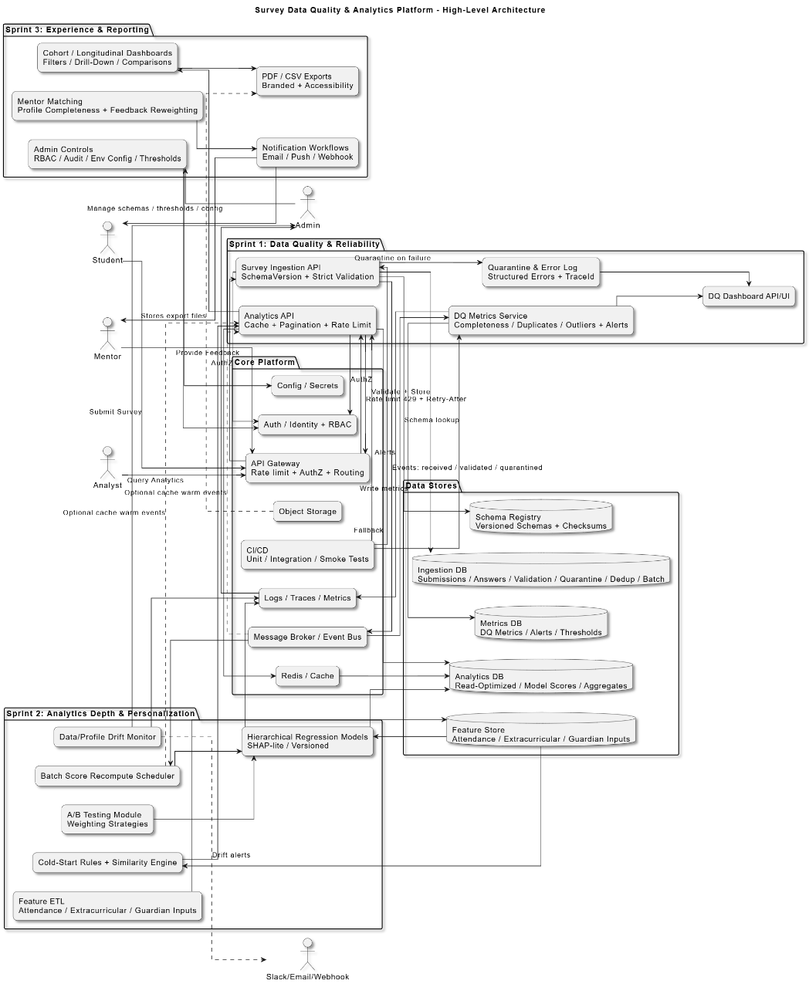
7 | METHODOLOGY  (not more than 10 points) | 1. Define versioned survey schemas and enforce strict validation rules to ensure data consistency.  2. Standardize error reporting with traceable logs and a status endpoint for monitoring ingestion issues.  3. Stage and validate existing surveys, quarantining invalid entries with summary reports.  4. Compute data quality metrics—completeness, duplicates, and outliers—after each ingestion batch.  5. Build a lightweight dashboard to visualize data quality trends and batch-level drill-downs.  6. Configure automated alerts via Slack/email/webhook for threshold breaches in data quality metrics.  7. Implement caching, pagination, and rate limiting on analytics APIs to improve performance and reliability.  8. Enable CI-based test coverage for ingestion and analytics modules with deploy-time smoke tests.  9. Apply hierarchical regression and sentiment-based analytics to quantify student career confidence.  10. Generate interactive dashboards and automated reports to support data-driven guidance and mentor decisions.
8 | OUTCOMES OR DELIVERABLES  (not more than 5 points) | 1. Versioned survey schemas with a strict validation system, standardized error reporting, and traceable ingestion logs.  2. Clean and validated survey dataset (1,000 existing records processed + ready for new surveys) with quarantined invalid entries and summary reports.  3. Data quality dashboard displaying completeness, duplicates, and outliers, with alerting integrated via Slack/email/webhook.  4. Hardened analytics APIs featuring caching, pagination, and per-user/API-key rate limiting with 429 responses and retry guidance.  5. Continuous integration pipeline with coverage gates, published reports, and deploy-time smoke tests ensuring ingestion-to-analytics reliability.
9 | NOVELTY  (not more than 3 points) | 1. Integrates socio-economic, behavioral, academic, and role-model factors into a unified, data-driven framework for holistic assessment of student career confidence.  2. Applies hierarchical regression and sentiment-based analytics to provide explainable, multi-level insights that quantify the relative influence of diverse factors.  3. Combines interactive dashboards, automated reporting, and mentor alignment features to deliver personalized, evidence-based career guidance in a scalable and reproducible manner.
10 | Time line | Deliverables
 | November 2025(Review 0) | Project proposal submission, initial research objectives, survey design draft, preliminary literature review.
 | January 2026 (SPRINT Review 1) | Sprint 1 completion: survey ingestion hardening, initial dataset validation, data quality dashboard prototype, basic analytics API setup, daily scrum & review documents.
 | March 2026 (SPRINT Review 2) | Sprint 2 completion: expanded data features, hierarchical regression model, explainability analysis, cold-start recommendations, batch recomputation and monitoring, updated dashboards.
 | April 2026 (SPRINT Review 3) | Sprint 3 completion: cohort/trend dashboards, PDF/CSV reporting, mentor matching v2, admin controls, CI pipeline, final research article draft, ready for Research Day presentation.
11 | Collaboration details | 1. Atharv Dobhal – Backend + Analytics  2. Divyansh Bafila – Frontend + Dashboard Design
12 | Target Technology Readiness Level of the project  (TRL Scale 1 to 9)  TRL 1 -Basic principles observed and reported.  TRL 2 -Technology concept formulated.  TRL 3 -Experimental proof of concept.  TRL 4- Technology validated in lab.  TRL 5- Technology validated in a relevant environment.  TRL 6 -Technology demonstrated in a relevant environment.  TRL 7- System prototype demonstration in operational environment.  TRL 8- System complete and qualified.  TRL 9- Actual system proven in operational environment. | TRL 6 -Technology demonstrated in a relevant environment.
13 | Sustainable Development Goal (1-17) ( Most prominent one goal) | SDG 4 – Quality Education
14 | Industry Practice followed for system development ( Agile- SCRUM) | Roles: One student acts as Product Owner (manages backlog, priorities), the other facilitates as Scrum Master; both contribute to development.  Events: Sprint Planning to set goals, Daily Scrum (10–15 min sync), Sprint Review (demo & feedback), Sprint Retrospective (process improvement).  Artifacts: Shared Product Backlog, Sprint Backlog, working Increment; clear Definition of Ready/Done.  Cadence: 1–2 week sprints with timeboxed tasks.  Backlog Refinement: Regular grooming, clear acceptance criteria, small vertical tasks.  Transparency: Shared boards and burn-down charts; working software visible each sprint.  Quality: Unit tests, CI for backend/frontend, code reviews between the two.  Stakeholder Engagement: Demo thin slices to supervisor, incorporate feedback, adjust priorities.  Risk Management: Surface blockers early, spike tasks for unknowns, manage dependencies together.  Metrics: Track flow, lead time, and defects to improve process iteratively.

Conference/Journal Publication/Patent Details (Mandatory, Target Publication a)
Annals of R.S.C.B., ISSN:1583-6258, Vol. 25, Issue 6, 2023

Signature of Students: 1.

2.

Signature of the Supervisor:

